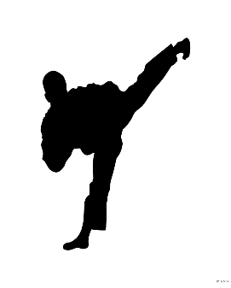
TAYLOR’S TAE KWON DO
TUMBLING & DANCE
Woodville Studio

Guidelines: Martial Arts, Tumbling and Dance studios are permitted to operate under the following guidelines, per the Governor and Health Departments.
*Use hand sanitizer when entering and exiting the classroom.
*Maintain a safe distance from one another.
*All instructors are required to wear a face covering.
*It is recommended that students wear a face covering,
(unless there are health conditions where it is advised not to).
*Also, please stay home if not feeling well. Take temperature before coming to class.

Summer classes: Begin the week of June 15th. (Remember, no classes June 29-July 5)
*All classes will be held upstairs in the air-conditioned gym
*Please enter through main doors. The students will exit through the gymnasium side door.
*Everyone needs to fill out and sign the waiver/registration form before participating in class.
*The classes will be scheduled with 15 minute increments between each class. This will eliminate the number of people in entry way, etc. The waiting room will be closed. Parents should stay in their car, if possible, while your child is in class. You are welcome to bring a bag chair to sit outside.
*Parents of preschool aged children are permitted, but only 1 parent per child. No other siblings. You may be asked to sit in your child’s square throughout their class.

Class space: The class space will look different as well. There has been squares taped out on the floor. Each child will stay in its work out square for the entire class.
*Be sure they go to the restroom and wash their hands before entering class.
*They should bring their own water bottle (please water only).
*They will be bringing their dance bags into the gym. We will not be using the cubbies at this time. They will also need a separate bag to put their street shoes in, to bring into the gym.

* No Barefeet. All students need to wear
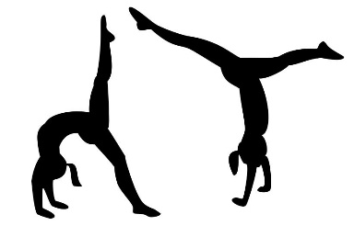
Dance, Tumbling or Tae Kwon Do Shoes in the gym.

Acro shoes are available for tumbling students through the studio - $18.
(Let me know what size you need)

Tae Kwon Do shoes are available through Century Martial Arts.
Please text Master Taylor for the promo code.

Any questions, please call 419-704-4407.

